**Teaching-learning activities**

1. Realise the physical design of the COMPANY database.

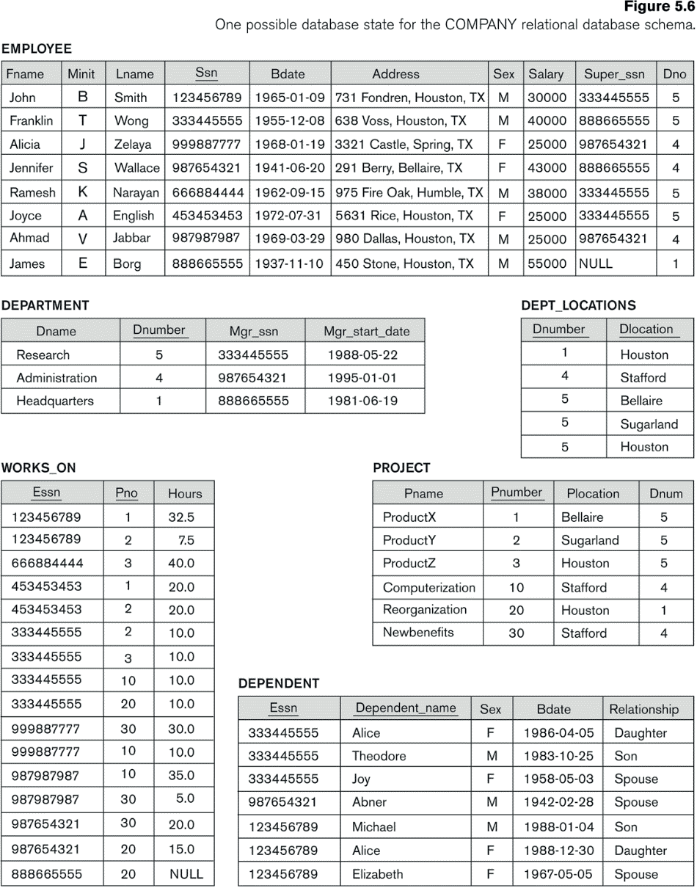

**Use the SQL language to carry out the exercise.**

1. The following modifications must be made in the ***Company*** database:

- Remove the Adress field from the Employee table.

ALTER TABLE EMPLOYEE DROP COLUMN Adress CASCADE;

- Add a column in the Project table called Hours that will indicate the duration in hours for each project.

ALTER TABLE PROJECT ADD COLUMN Hours (int);

- Removes the Mgr_start_date field from the Department table.

ALTER TABLE DEPARTMENT DROP COLUMN Mgr_start_date CASCADE;

- Rename the Relationship column in the Dependent table to Family.

ALTER TABLE DEPENDENT CHANGE Relationship Family VARCHAR(8);

2. Carry out the physical design of the ***Startrek*** exercise worked on in previous units (without specialization)

- The tables should be created.

**CREATE TABLE ACT-PER** (

cod_actor CHAR (25) NOT NULL

nombre VARCHAR (25) NOT NULL

fecha DATE NOT NULL

nacionalidad VARCHAR(25)

cod_per VARCHAR (25) NOT NULL

super_per CHAR (9)

nombre_p VARCHAR (25) NOT NULL

raza VARCHAR (20) NOT NULL

grado VARCHAR (20)

**PRIMARY KEY (**cod_actor),

**UNIQUE** (cod_per),

**FOREIGN KEY** (Super_per) **REFERENCES** ACT-PER (cod_actor));

**CREATE TABLE CAPÍTULO** (

orden INT NOT NULL

temporada INT NOT NULL

titulo VARCHAR (25) NOT NULL

fecha DATE NOT NULL

**PRIMARY KEY** (orden, temporada));

**CREATE TABLE APARECE** (

orden INT NOT NULL

temporada INT NOT NULL

cod_actor CHAR (25) NOT NULL

**PRIMARY KEY** (orden, temporada, cod_actor),

**FOREIGN KEY** (orden, temporada) **REFERENCES** CAPÍTULO (orden, temporada)

**FOREIGN KEY** (cod_actor) **REFERENCES** ACT-PER (cod_actor));

**CREATE TABLE PLANETA** (

cod_planeta VARCHAR (20) NOT NULL

galaxia VARCHAR (20) NOT NULL

nombre VARCHAR (20) NOT NULL

**PRIMARY KEY** (cod_planeta));

**CREATE TABLE VISITA** (

orden INT NOT NULL

temporada INT NOT NULL

cod_planeta VARCHAR (20) NOT NULL

problema VARCHAR (25) NOT NULL

**PRIMARY KEY** (orden, temporada, cod_planeta)

**FOREIGN KEY** (orden, temporada) **REFERENCES** CAPÍTULO (orden, temporada),

**FOREIGN KEY** (cod_planeta) **REFERENCES** PLANETA (cod_planeta));

**CREATE TABLE PELÍCULA** (

cod_pelicula VARCHAR (20) NOT NULL

año INT NOT NULL

titulo VARCHAR (20) NOT NULL

director VARCHAR (20) NOT NULL

cod_actor CHAR (25) NOT NULL

**PRIMARY KEY** (cod_película),

**FOREIGN KEY** (cod_actor) **REFERENCES** ACT-PER (cod_actor));

**CREATE TABLE APARECE2** (

cod_pelicula VARCHAR (20) NOT NULL

cod_actor CHAR (25) NOT NULL

**PRIMARY KEY** (cod_película, cod_actor),

**FOREIGN KEY** (cod_actor) **REFERENCES** ACT-PER (cod_actor),

**FOREIGN KEY** (cod_pelicula) **REFERENCES** PELICULA (cod_pelicula));

3. The following modifications should be made to the ***Startrek*** database created in the previous exercise.

- Add the City column to the PERSONAJE table.

ALTER TABLE PERSONAJE ADD COLUMN City VARCHAR (12);

- Add the column Birth_Date to the PERSONAJE table.

ALTER TABLE PERSONAJE ADD COLUMN Birth_Date (DATE);

- Remove the column galaxia in the PLANETA table.

ALTER TABLE PLANETA DROP COLUMN galaxia CASCADE;

- Rename the columns “grado” to “categoría” in PERSONAJE table.

ALTER TABLE PERSONAJE CHANGE grado categoria VARCHAR (20);